Task 1 : Ansible

**Problem Statement:**

Configure Ansible to deploy webserve, and bring it up a port 80 with a web page that is publically accessible that displays the message: “Hello World”.

Include in the Ansible playbook, plays to deploy and un-deploy the resources

**Solution**:

We will be performing this task on 2 AWS EC2 instances (virtual machines). Where one instance will act as the control machine or master and other will act as host where we will be deploying/undeploying webserver.

**Step 1:**

Launch 2 EC2 instances:

Instance1: IP Address: 52.14.249.139 (control_machine)

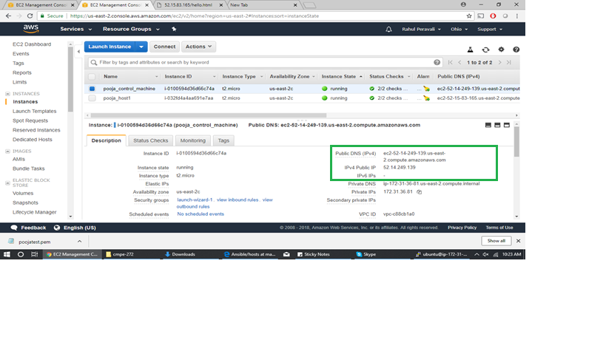

Instance 2: IP Address: 52.15.83.165 (host1)

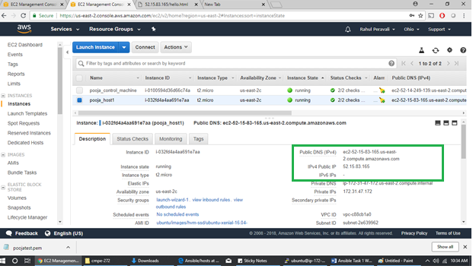

**Step2:**

Login to the instances using ssh key-pair.

Create SSH connection between 2 instances using Key-Pair. (using pem file or ssh-keygen command and copy as below)

Go to .ssh folder of control machine :

vi id_rsa (copy the pem file content here and save)

chmod 400 id_rsa

ssh-keygen -f ~/.ssh/id_rsa -y > ~/.ssh/id_rsa.pub (copy the public key to the id_rsa.pub)

ssh-copy-id [ubuntu@52.15.83.165](mailto:ubuntu@52.15.83.165) (to copy the key in authorized_keys of instance 2)

ssh [ubuntu@52.15.83.165](mailto:ubuntu@52.15.83.165) (should be able to connect to the host machine)

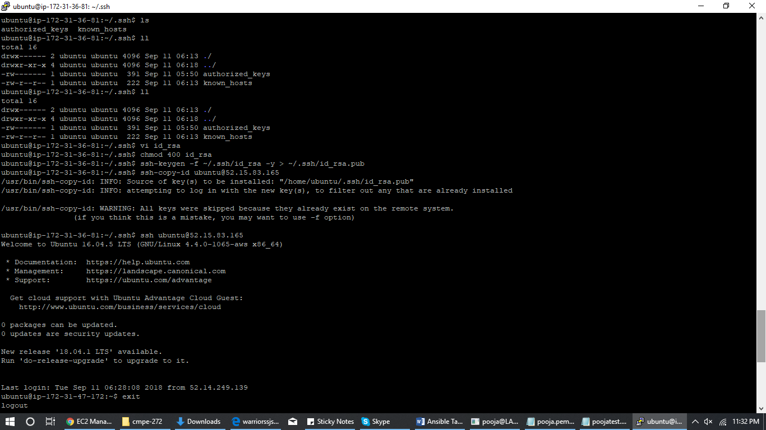

**Step 3:**

Once connection is established i.e. you are able to ssh to host from control machine. Install ansible on control_machine using following commands:

sudo apt-get install software-properties-common

sudo apt-add-repository ppa:ansible/ansible

sudo apt-get update

sudo apt-get install ansible

**Step 4:**

Go to /etc/ansible/hosts to check the host file:

Add the host IP address :

[webservers]

52.15.83.165



**Step 5:**

Check that you are able to ping the added webserver :

ansible webservers -m ping

or

ansible all -m ping (since we have just one host at this moment and only one to deploy to)

It says python not installed on host machine, so installed python on host 52.15.83.165

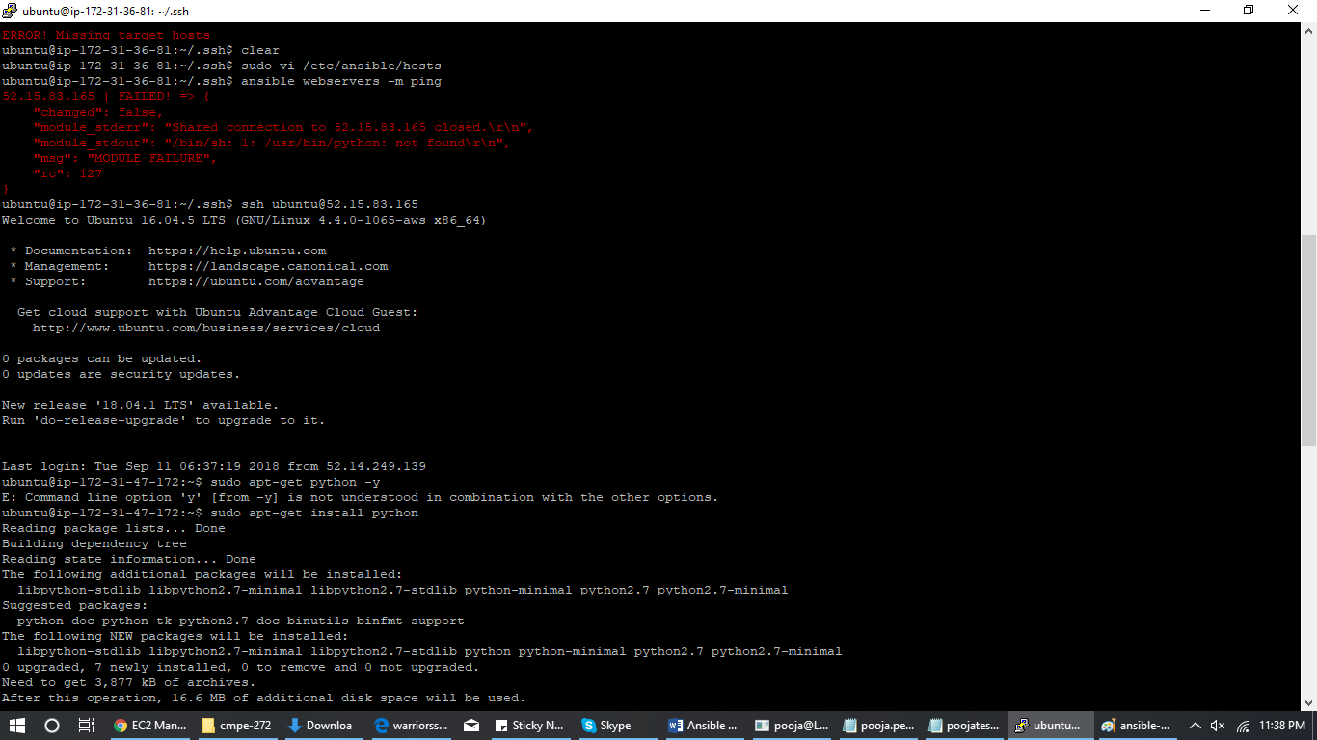

Tried ping again:

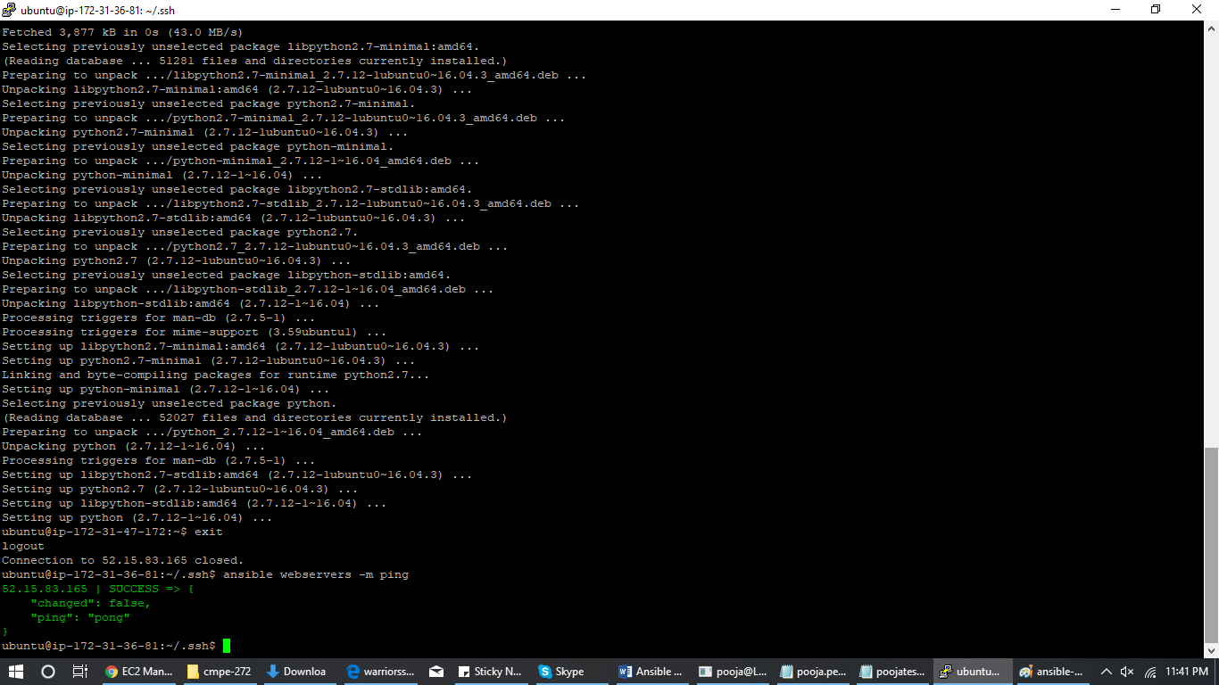

Successful!

**Step 6:**

Create an html page hello.html



**Step 7:**

Deploy a webserver on host machine using ansible playbook on control machine:

playbook_webserver_deploy.yml

Add variable http_port: 80



**Step 8:**

Once the apache2 server has been installed and started, deploy html file:

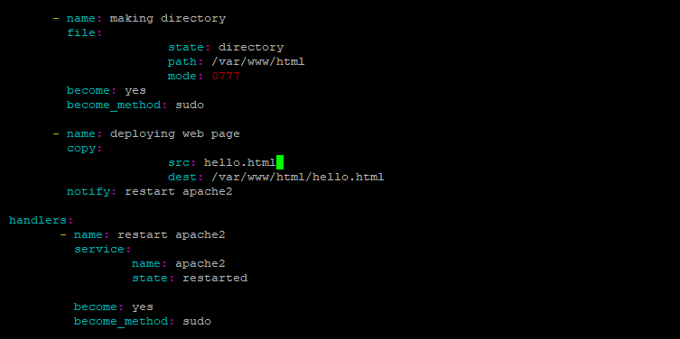

Note: we have added one handler here just to keep our webserver alive.

**Step 9:**

Run the playbook and see the output as below:

ansible-playbook playbook_webserver_deploy.yml

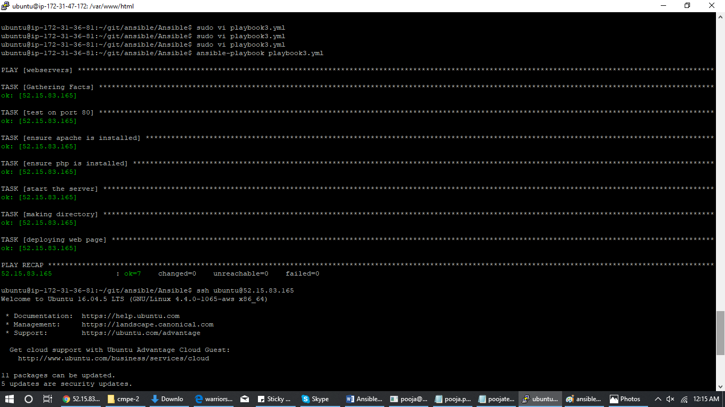

All tasks Successful!

**Step 10:**

Go to the web browser and open the html file:

http://52.15.83.165:80/hello.html



**Step 11:**

Undeploying resourses using ansible:

playbook_webserver_undeploy.yml



Run the playbook to undeploy apache2 and php on host machine

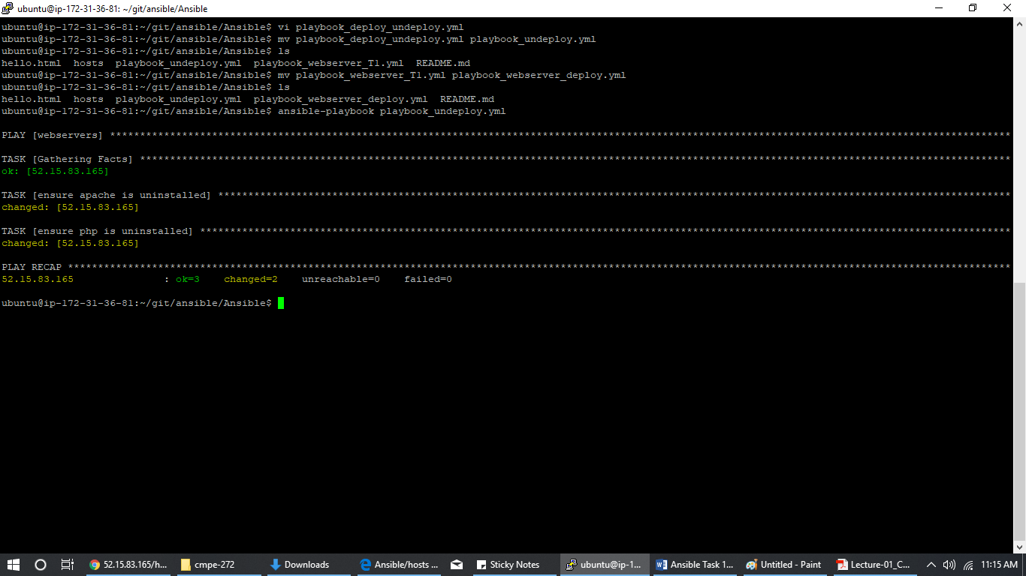

Can check the webpage again and it will not show anything:



Note: we have **re-run** the playbook to deploy webserver and webpage for verification purposes. So currently our host machine is running the webserver.

Thanks

Team Warriors